**FUNDAMENTALS OF COMPUTING**

**DAY-1**

**1**.Generation of number series 1,2,3,……,n.

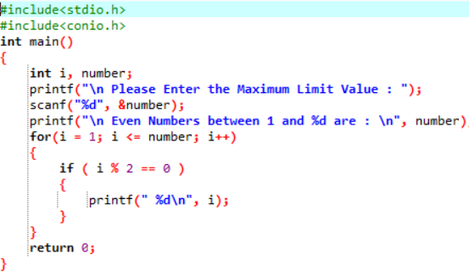

**OUTPUT:**

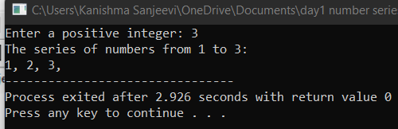

**2**.Generation of even number series.

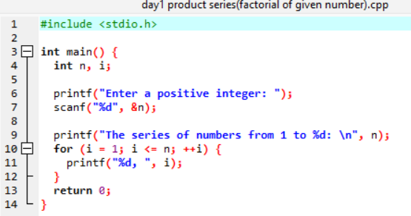

**OUTPUT:**

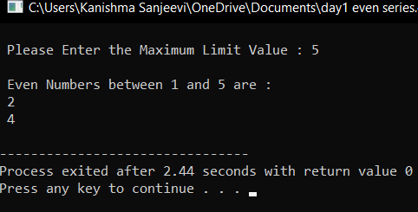

**3**.Generation of odd series.

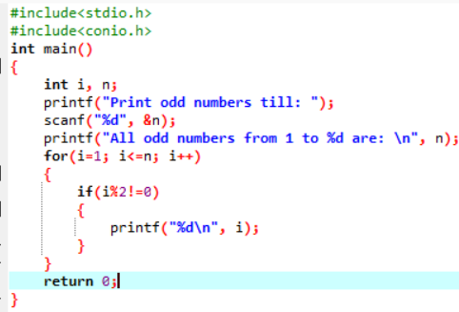

**OUTPUT:**

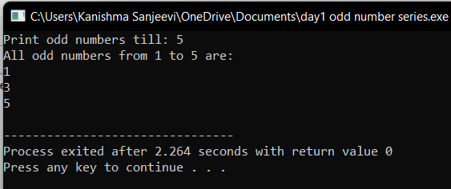

**4**.Generation of Fibonacci series.

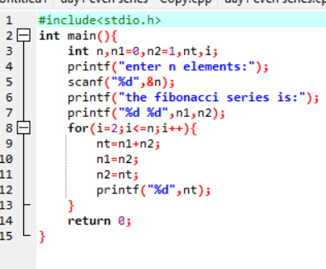

**OUTPUT:**

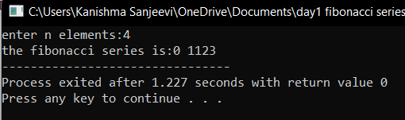

**5**.Summing up series 1+2+3+…..+n.

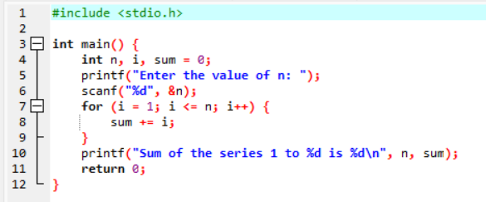

**OUTPUT:**

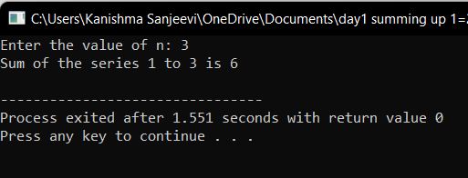

**6.**Summing up of even number series.

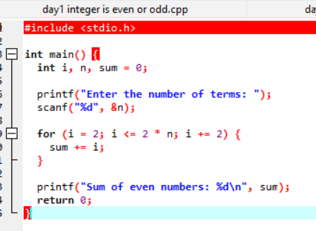

**OUTPUT:**

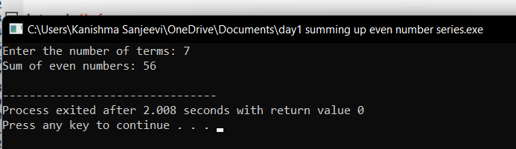

**7.**Summing up of cube of n numbers.

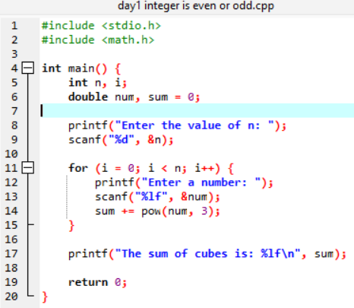

**OUPUT:**

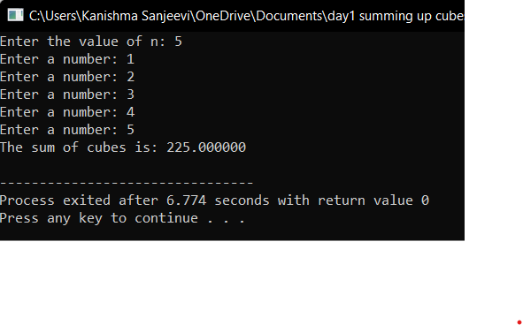

**8.**Finding whether the given number is even or odd.

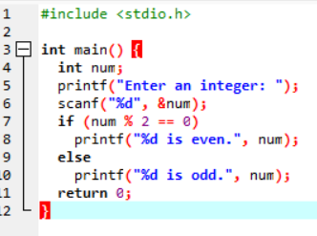

**OUTPUT:**

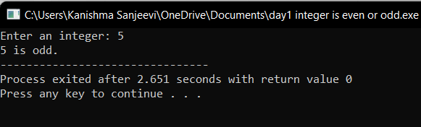

**9.**Product series ( Factorial of given number).

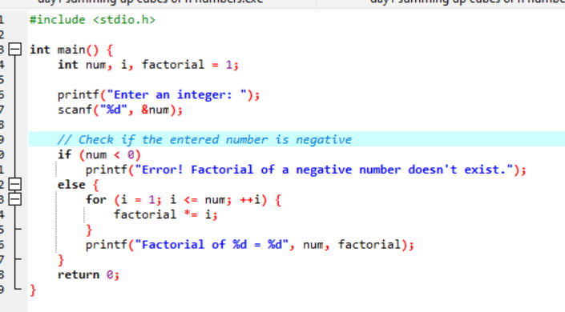

**OUTPUT:**

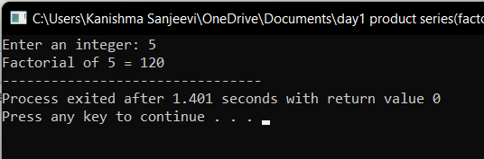

**10.**Find the given number is Armstrong or not.

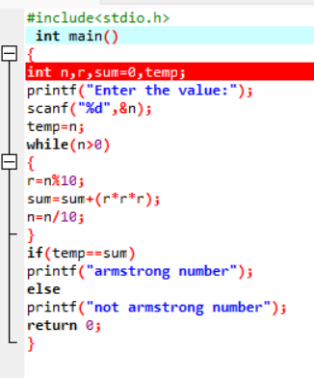

**OUTPUT:**

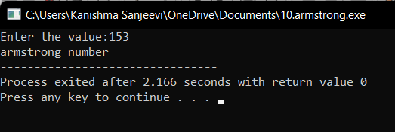

**14.**Reversing the digits of an integer.

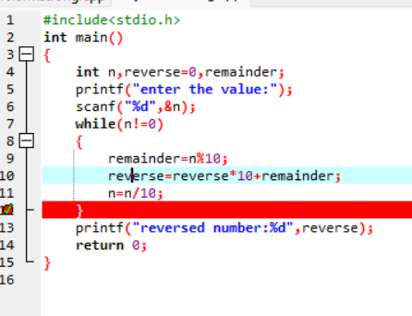

**OUTPUT:**

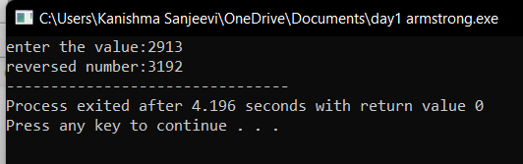

**15.**Finding the given integer is positive or negative.

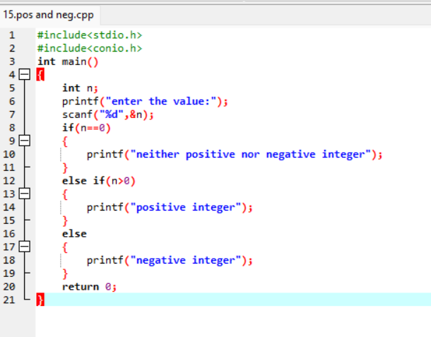

**OUTPUT:**

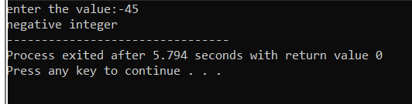

**16.**Swamping two numbers with two temporary variables.ss

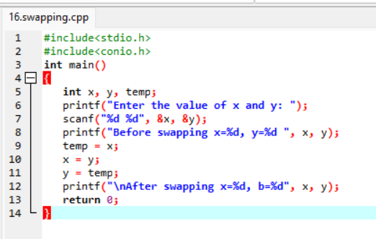**s**

**OUPUT:**

